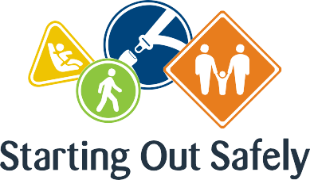

National Practice: Assessment for learning

**Together with children and families, reflect on each child’s learning and application of road safety to plan for future learning.**

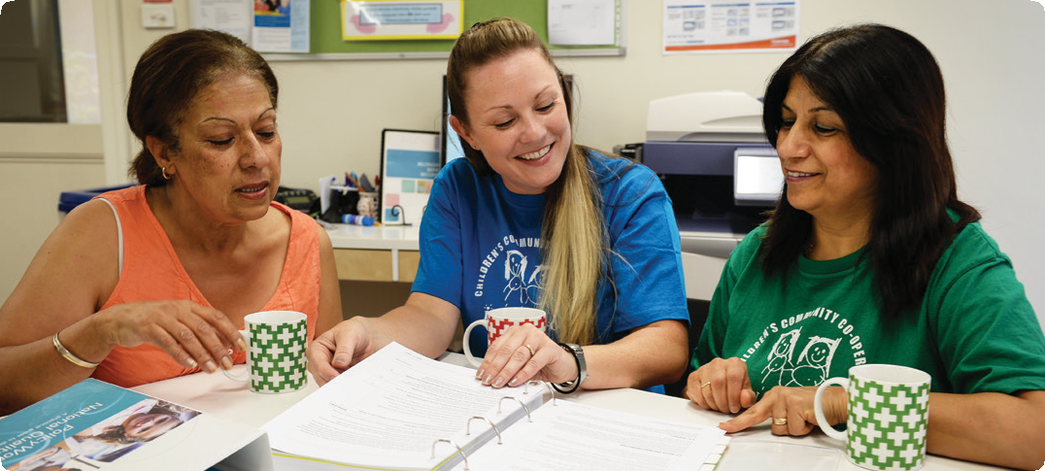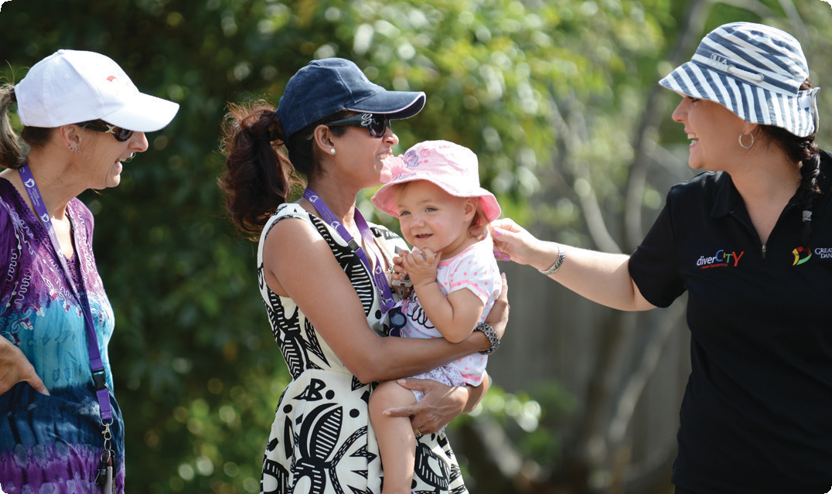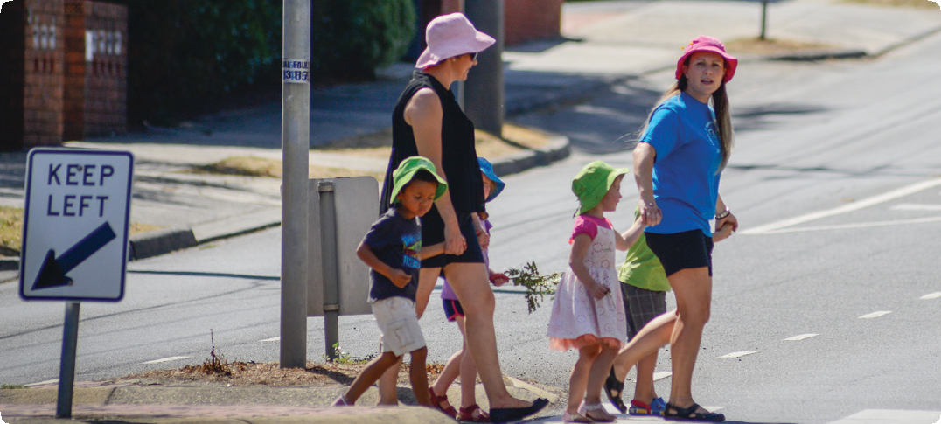

Assessment is the first step in determining what children know about road safety. As children’s abilities and dispositions vary widely, it is important to view children’s learning in both cultural and family contexts, and to undertake assessment collaboratively with families. This not only encourages a positive partnership, but also ensures that road safety education is consistently role-modelled in both the home and the early childhood service environments.

This process of gathering information about children’s road safety understanding from various sources, allows educators to assess children’s knowledge, strengths, dispositions and interests. This knowledge enables educators to plan and evaluate appropriate road

safety education and to support further learning.

Road safety education is most effective when it is embedded in everyday experiences in services rather than left to a ‘theme week’ once a year.

Connections

Early Years Learning Framework (EYLF)

“Assessment for children’s learning refers to the process of gathering and analysing information as evidence about what children know, can do and understand” (*Belonging, Being & Becoming – The Early Years Learning Framework for Australia*, 2009 p.17).

National Quality Standard

**Quality Area 1: Educational program and practice**

1.2.1: Each child’s learning and development is assessed as part of an ongoing cycle of planning, documenting and evaluation.

1.2.2: Educators respond to children’s ideas and play and use intentional teaching to scaffold and extend each child’s learning.

Road Safety education in practice

**Case Study 1:** For both children and their families, assessment practices can highlight the outcomes children have achieved and how their learning can be supported into the future. For one particular sessional-based preschool service, summary assessment reports have provided this opportunity for children who were preparing to enter school the following year. The service’s team of educators completed a transition statement that detailed each child’s learning and summarised the ‘distance travelled’ in relation to the five learning outcomes in the EYLF. The report also highlighted the key learnings for each child in relation to a major project that focused on pedestrian and cyclist safety. This project had emerged because of the service’s location near a busy intersection, but was also significant as most of the children would later be attending a school located on a busy highway. Feedback from families and the school about the inclusion of this information in the transition statements has been positive and has assisted further planning with children, families and the school about safe arrival to and departure from this school.

**Case Study 2:** Assessment for learning can assist children to revisit prior learning from particular events. A Family Day Care educator took her group of children (aged 18 months to 4 years) on regular excursions around the neighbourhood, following different routes to reach the local library. The children experienced and observed a variety of people, places and activities on these outings. The educator and children took photos as they went, and worked together to create a book about the things they had seen and done on their trips, when ducks crossed the road, when a new set of traffic lights were installed, when a group of cyclists rode by and when a fire engine came rushing past. The book had a special place in the educator’s home and children frequently read the book and shared their memories of the events with one another. The educator used these opportunities to assess children’s understanding of road safety and to support them to continue their learning towards becoming safer road users.

Practice suggestions

**Road safety education is supported when educators use the Early Years Planning Cycle to inform their curriculum decisions.**

The cycle and its individual stages, as described in the *Educators’ Guide to Early Years Learning Framework for Australia* (p.11), offers a structure that educators can use to gather and document data about children’s knowledge and understanding of road safety, to assess children’s developing competencies, to plan and implement learning experience that promote safe behaviours and to review and reflect on the effectiveness of strategies in particular contexts.

The following suggestions can assist educators in using the planning cycle to promote road safety education.

* Educators can collect data on children’s current understanding through conversations. By engaging in meaningful conversations that support children to articulate their knowledge, educators can learn about each child’s understanding of road safety concepts. Conversation starters may include questions such as:
* Tell me about your trip to preschool today (or walk to the park etc.)
* I wonder why we need to wear a helmet when we ride our bikes
* What would happen if there were no cars, trains or buses? How would we get around?
* Documentation describing children’s experiences

in learning about road safety allows educators to create opportunities for further learning. When this documentation is accessible to children, they can revisit their play and assess their own learning by looking through this documentation and using their recall to stimulate future experiences.

* The *question or analyse* process, particularly when connected to documentation, invites educators to track the development of children’s road safety knowledge, including their road safety vocabulary, concepts, skills, behaviours and attitudes.
* Reflect and review: When educators reflect on children’s learning about road safety, they can adapt and refine the learning environment and their own practice to promote future learning.
* Educators can encourage children to collect and record information about their experience of road safety as a way to assess what children know, can do and understand about being safe in the community.

**Further information** For more information about Starting Out Safely activities and resources please visit: <http://roadsafetyeducation.vic.gov.au/resources/early-childhood.html>