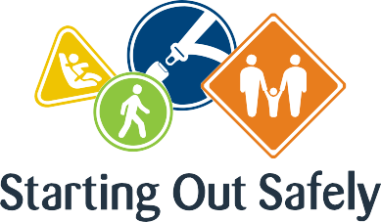

National Practice: Continuity of learning and transitions

Use the opportunity of transitions, in active partnership with children, families and the local community, for road safety education.

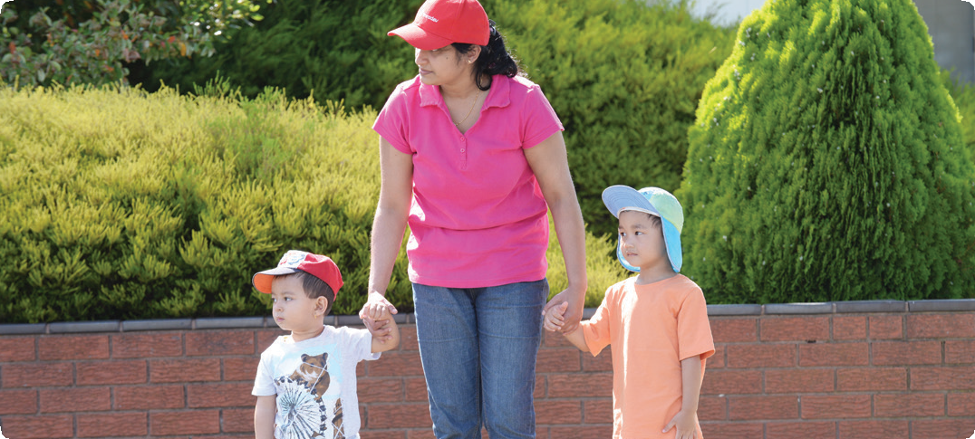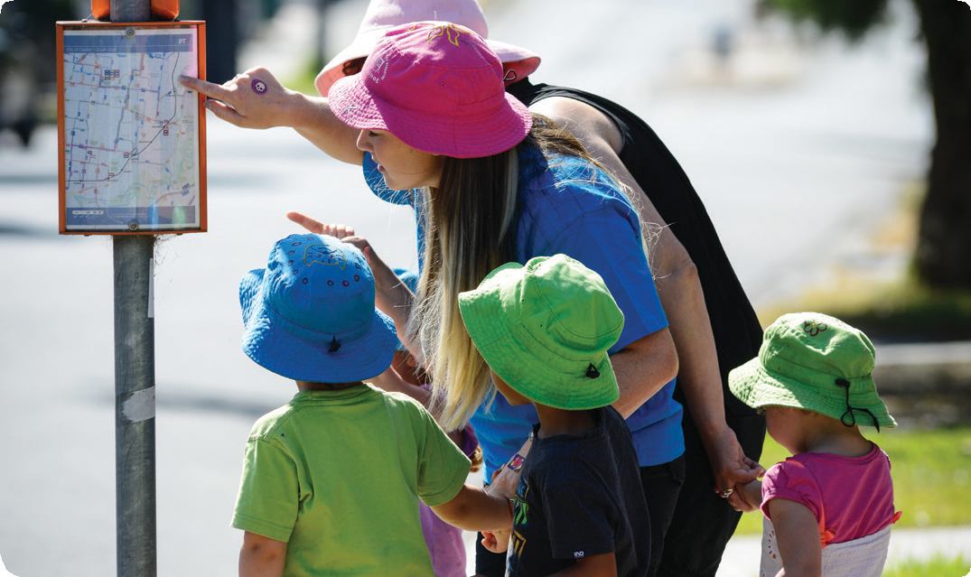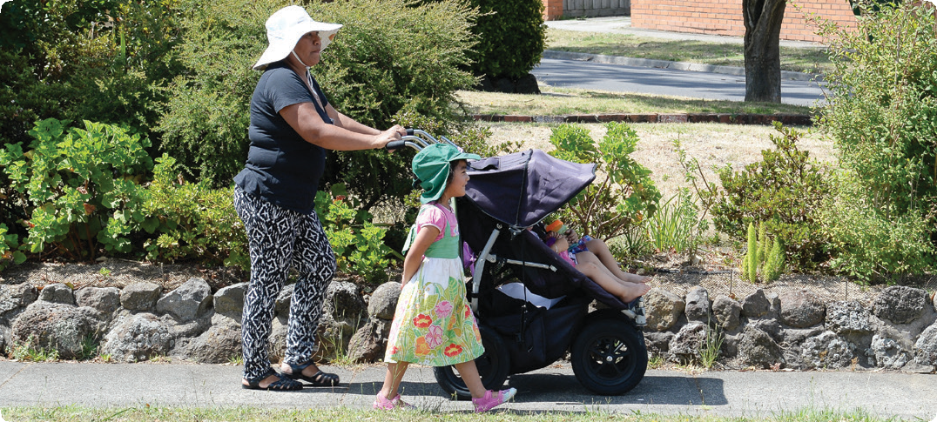

Transitions to, from and within early childhood programs offer young children rich opportunities for learning and development.   
The experience of moving successfully from one group or space to another, or one experience to another, equips children to manage their everyday lives now and into the future. When educators pay attention to these times, focusing on continuity and intention, they maximise the possibilities for holistic learning that incorporates physical, cognitive, social and emotional development.

Transitions provide great opportunities to embed road safety education into the curriculum. Transitions to/from the service and transitions across age groups or to school offer opportunities for children to learn to take increasing responsibility for their own safety and wellbeing and that of others.

When children use transition times to practise the skills, attitudes and behaviours that help them to be safe and manage risk, there are lasting benefits.

Connections

Early Years Learning Framework (EYLF)

“Children bring family and community ways of being, belonging and becoming to their early childhood settings. By building on these experiences educators help all children to feel secure, confident and included and to experience continuity in how to be and how to learn” (*Belonging, Being & Becoming – The Early Years Learning Framework for Australia*, 2009 p.16).

National Quality Standard

**Quality Area 6: Collaborative partnerships with families and communities**

6.3: The service collaborates with other organisations and service providers to enhance children’s learning and wellbeing.

6.3.2: Continuity of learning and transitions

for each child are supported by sharing relevant information and clarifying responsibilities.

Road Safety education in practice

**Case Study 1:** Transition visits as children prepare to enter primary school offer an excellent opportunity for children across all ages groups (not only children who will be entering school) to engage in meaningful road safety education.

A kindergarten service in a suburban community has made a particular effort to support children and their families’ transition to school. The team of educators were concerned by conversations where parents had expressed anxiety about their children walking on the footpath outside the school, given its location on a busy dual-lane highway.

The educators planned a series of opportunities across the year to equip children and their families to become safer and more confident road users. This included teaching children the importance of holding hands with an adult near roads and what to look out for when preparing to cross a road. Parents were also invited to participate in these planned opportunities. In addition, walks around the neighbourhood to practise crossing roads safely and regular visits to the school (located around the corner from the service) helped everyone feel more confident.

**Case Study 2:** A small rural service was approached by a parent requesting that their four-year-old child catch the school bus to the kindergarten (next door to the school) with their older next-door neighbours. The educator and management team were initially concerned about the young child catching a bus on her own, but after further discussion with the family, understood that this was likely to be the only way that this child could participate in kindergarten. The management team and educators worked together with the family, bus company and bus driver to develop clear policies and procedures that supported children to be safer passengers and

pedestrians, including procedures for signing children in and out of the service, the wearing of seatbelts, and getting on and off the bus. The educators developed a roster to ensure that someone would be available to meet the child at the bus stop and walk with her to the kindergarten. The educators actively included arriving to the kindergarten on the bus as part of their transition planning.

Practice suggestions

**Opportunities to support effective transitions present throughout the program and across the year.**

Educators might consider the following ideas to embed road safety education into the program.

* At enrolment and settling-in times, talk to children and their families about the various ways to travel safely to the service, e.g. holding hands as you walk along the footpath, making sure that the correct child restraint and booster seat are used, getting out of the car on the kerb side, crossing the road safely and closing the gate behind you.
* Invite children to discuss the ways they travel to from the service, and how they might do this a safe way. This could include using local road safety education materials and resources that support children to learn specific skills, attitudes and behaviours.
* Use the enrolment interview process with families to alert them to any particular traffic hazards at and around the service (tricky intersection or busy car park), and offer advice on how to manage these safely.
* Encourage children to think and plan for how they leave the service. Perhaps children can make a list or create a book that helps them remember. Engage children in understanding how their actions (e.g. holding hands, waiting for their parent/carer to be ready to leave, walking rather than running can help keep them safe.
* Make particular efforts to visit places in your local community, including the school. These and experiences offer children real opportunities to in practise being safe pedestrians.

**Further information** For more information about Starting Out Safely activities and resources please visit: <http://roadsafetyeducation.vic.gov.au/resources/early-childhood.html>