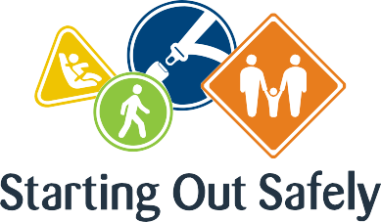

National Practice: Cultural competence

**Implement road safety education that is culturally relevant for the diversity of children, their families and the community.**

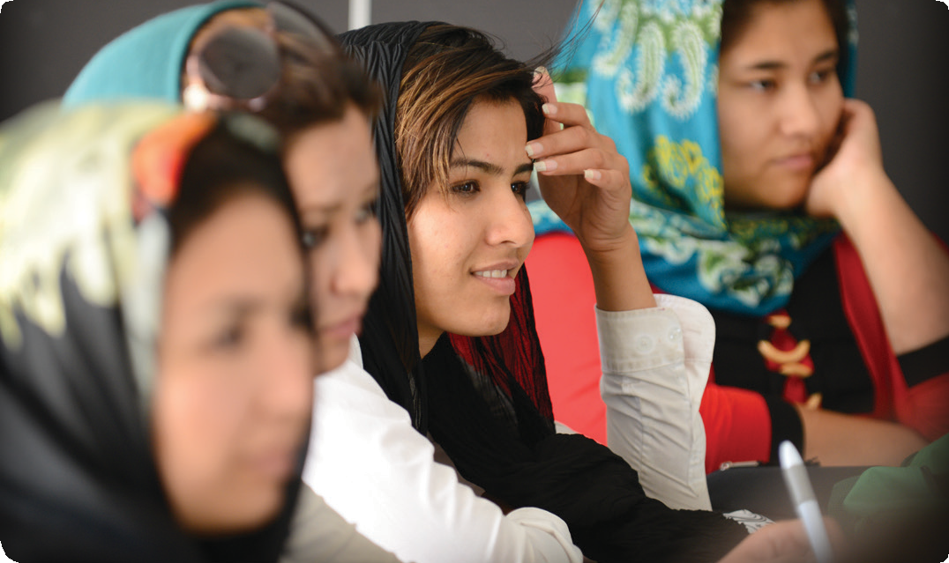

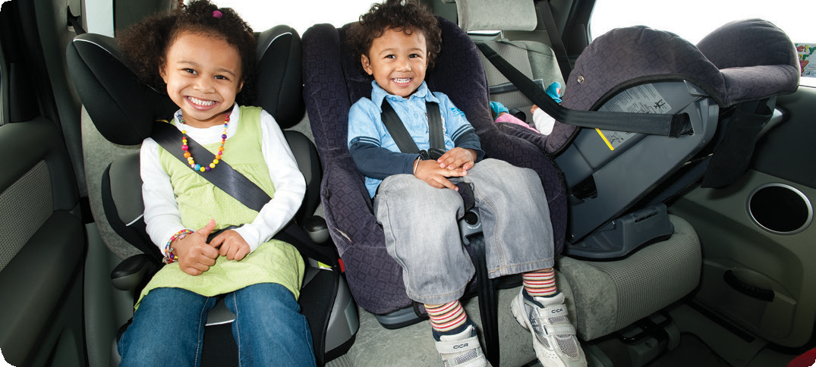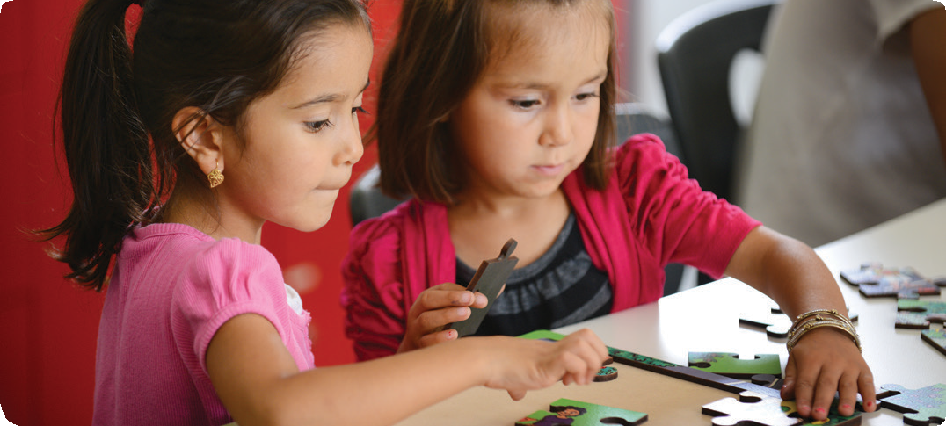

Being culturally competent focuses on an educator’s capacity to respectfully respond and understand diverse ways of living. When these perspectives are incorporated into programs for children and their families, differences are celebrated and individuals feel a greater sense of belonging and connectedness. For the most part, this practice is more about being patient and inclusive rather than only utilising a set of activities and resources.

Children’s experience and understanding of being road users is shaped by that of their families. This can be a complex story, particularly for families who are newly settled in Australia and who may have experienced different rules and cultural attitudes to road safety in other countries.

**Supporting safe road use in culturally sensitive and inclusive ways will ensure children and families become active participants in community life.**

Connections

Early Years Learning Framework (EYLF)

“Educators who are culturally competent respect multiple cultural ways of knowing, seeing and living, celebrate the benefits of diversity and have an ability to understand and honour differences” (*Belonging, Being & Becoming – The Early Years Learning Framework for Australia*, 2009 p.16).

National Quality Standard

**Quality Area 1: Educational program and practice**

1.1.1: Curriculum decision making contributes to each child’s learning and development outcomes in relation to their identity, connection

with community, wellbeing, confidence as learners and effectiveness as communicators.

1.1.2: Each child’s current knowledge, ideas, culture, abilities and interests are the foundation of the program.

Road Safety education in practice

**Case Study 1:** For a rural Family Day Care service, road safety education needed to start with families. The town had recently seen a significant number of families settle in the community from southern Sudan, many with young children. The families were very new to Australia, having spent their initial settlement time in the inner city, and were still learning about the expectations of their new home. The service noticed that a number of children were arriving by car to Family Day Care without appropriate child restraints or seatbelts.

Educators attempted a conversation with the families, however it was difficult to explain the road rules as English was not a shared language. The staff and management sought advice on how to address this issue with families, meeting with a local community leader and the social worker responsible for supporting the families. Together they planned an information night in collaboration with a community leader and the local police to talk about the Child Restraint Road Rules and other local road safety issues. They also arranged for interpreters to be present to ensure families were able to participate. After the information night, the service noticed an improvement in the families’ use of appropriate child restraints and booster seats. Due to the success of the information night, the service plan to hold a similar event each year.

**Case Study 2**: Sometimes being culturally competent means looking at things from another perspective. A newly graduated educator started working at a preschool service in a diverse community. During her first month at the service, she became concerned about the number of children who were being collected by older siblings (mostly teenagers), and their relaxed approach to both signing children out and the journey home. Her colleagues at the service informed her that families in that community (mostly South Sea Islanders) expected older siblings to play an important part in looking after younger children.

After some reflection, the team decided to talk to the families about the importance of keeping children safe in the road environment. Rather than discourage the practice, the educators actively supported the teenagers to role-model safe road user behaviours with their younger siblings. This support included planning the safest route home, walking the route with the teenagers, and talking about safe places to cross roads and the importance of holding hands with their siblings. The strategy has been working well and several of the teenagers have even indicated an interest in undertaking work experience at the service.

Practice suggestions

**The following are strategies that educators might consider when embedding road safety education in culturally competent ways.**

* Get to know the local community. Using local knowledge about the lives of individuals and groups within the community equips us to make informed decisions.
* Make contact with community leaders. This may take some time and effort but will pay off when there is a particular issue that must be addressed, such as the safe transportation of children in cars. Elders or leaders of the community can assist community professionals to promote key health and wellbeing messages.
* Talk to organisations or agencies who work in the local community in supporting children and families from diverse cultural backgrounds. These organisations may be able to assist you to understand the experience of road safety for families before they arrived in Australia, e.g. families may have previously been living in a country where seatbelts or child restraints were not required.
* Be sensitive and try to avoid judging families, particularly where English is not a first language. It can be hard to understand new rules and cultural attitudes, and many of us need help to engage our children in safe road practice. Role-modelling safe practices and teaching children road safety skills will also help make the whole family safer road users.
* Use bilingual workers or invite a parent to assist you to communicate the key messages around road safety. Parents can become safety champions and help other families to understand rules and expectations, and how to adopt safer road use strategies.
* Educators could collect images of their local community (in particular, places that families and children might visit regularly) and display them in the service to assist children and families to feel a sense of belonging and become more aware of how to use these spaces safely.

**Further information** For more information about Starting Out Safely activities and resources please visit: <http://roadsafetyeducation.vic.gov.au/resources/early-childhood.html>