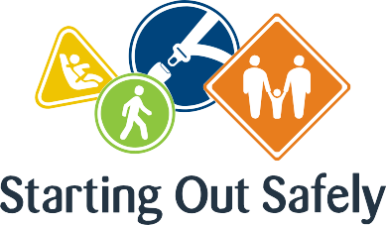

National Practice: Holistic approaches

**Recognise that children’s learning is integrated and interconnected when making curriculum decisions about road safety education.**

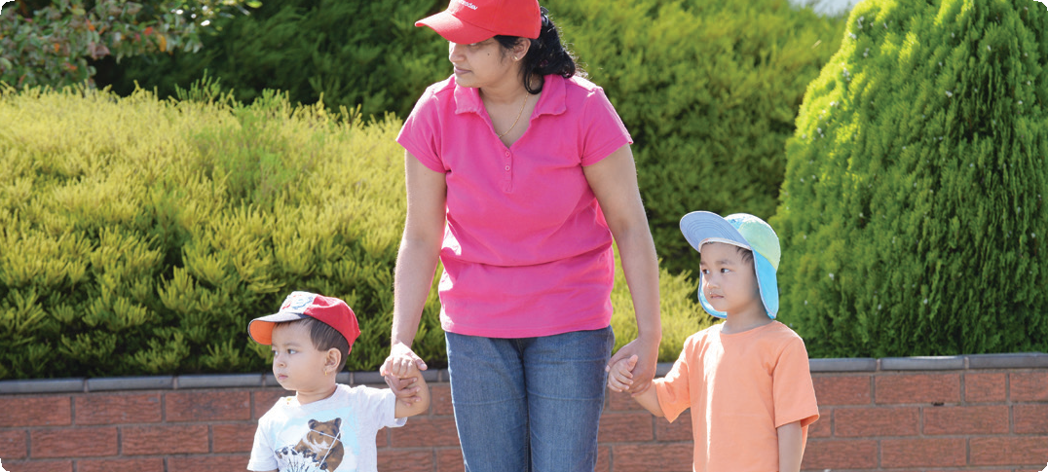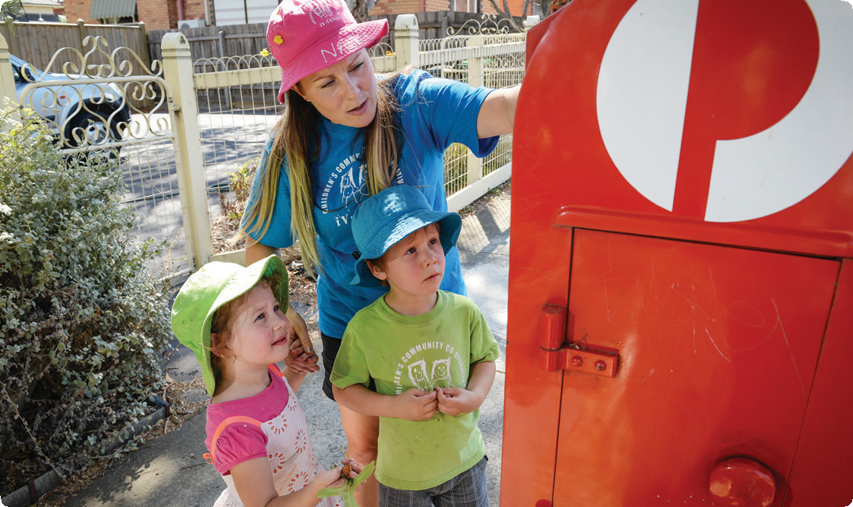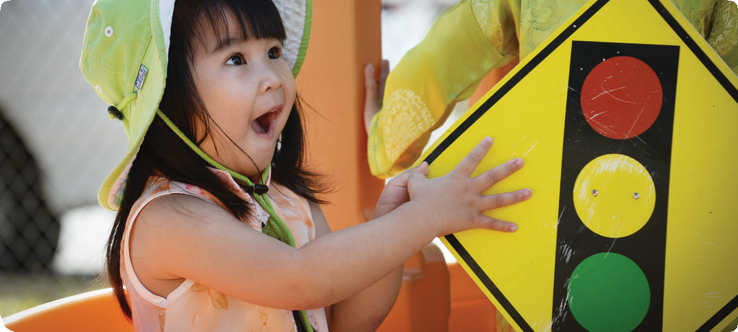

Holistic approaches ensure that children’s learning is interconnected and supports growth across all domains: cognitive, physical, social, emotional, linguistic and spiritual. This approach recognises that learning in the early years is most effective when educators attend to the whole child and weave together learning opportunities that connect different aspects of a child’s identity.

Making holistic curriculum decisions related to road safety education requires educators to consider multiple aspects of children’s learning. Road safety experiences that connect, for example, children’s physical, personal, social and cognitive aspects of learning provide for more meaningful learning.

**Using a holistic approach is fundamental to early childhood education. To be effective, road safety education for this age group must also adopt this approach.**

Connections

**Early Years Learning Framework (EYLF)**

“Holistic approaches to teaching and learning recognise the connectedness of mind, body and spirit. When early childhood educators take a holistic approach they pay attention to children’s physical, personal, social, emotional and spiritual wellbeing as well as cognitive aspects of learning… they see children’s learning as integrated and interconnected” (*Belonging, Being & Becoming*

*– The Early Years Learning Framework for Australia*, 2009 p.14).

National Quality Standard

**Quality Area 1:** Educational program and practice

1.1.3: The program, including routines, is organised in ways that maximise opportunities for each child’s learning.

**Quality Area 5:** Relationships with children 5.1.2: Every child is able to engage with educators in meaningful, open interactions that support the acquisition of skills for life and learning.

Road Safety education in practice

**Case Study 1:** Road safety education is about connectedness and community: about the way that children think about their becoming and feel about their belonging. In a small rural town, a team of educators in a sessional kindergarten program wanted to strengthen the connection between children and their community. As they discussed ways to do this, it became clear that in order to enable children to experience their local community though outings, they first needed to engage in road safety education. Educators explored available resources and noticed that they included references to walking along the footpath, using traffic lights and managing pedestrian crossings. However, their service was located on a dirt road with no footpaths and the town had no traffic lights, so the team of educators developed a range of holistic opportunities for the children that engaged their minds, bodies and spirits. An example of this was to walk to a place of local significance. These experiences supported children’s thinking on how to navigate and be safe on their adventures; acknowledging their bodies in the process of walking in all weather and on different terrain,

and their imaginations in the excitement that was generated throughout the project.

**Case Study 2:** A holistic approach to road safety education engages children’s minds, bodies and spirits. A long day care service in a large regional town considered the possibility of taking children to visit the elderly citizen’s home across the road as part of their regular weekly program. The educators were keen to include younger children in addition to the three and four-year-olds. They planned a series of conversations with the older children about what these visits would involve, how they could get there and back safely, and what they might need to bring with them on their visit. What happened over the next six months surprised everyone. The older children became increasingly skilled at looking out for the safety and wellbeing of their younger peers and advocating for crossing the road safely and holding hands with the adults. In addition, the relationships formed with the residents of the home brought great joy to everyone, including some of the parents who made a regular effort to be part of the visits.

Here, road safety education was an embedded strategy that enabled children’s connectedness to the community and to each other.

Practice suggestions

**Making holistic curriculum decisions engages a variety of learners and strengthens outcomes for children.**

There are a number of ways educators can make holistic road safety curriculum decisions. The following are some suggestions.

* Connect with children to gain insight into their interests and approaches to learning. Some children learn by doing (kinaesthetic learners) while others are motivated by the stories that surround concepts or ideas (linguistic learners). Understanding the nature of individual children supports holistic approaches and informs effective curriculum decisions.
* Choose road safety education opportunities that invite children to use their minds, bodies, spirits and imagination. Consider adding elements to play spaces that connect these aspects. For example, read a story about travelling by car and then invite children to construct a car with blocks. Extend this approach by supporting children to imagine where they might go in their car and what they need to do to stay safe in the car.
* Add physical elements to road safety teaching opportunities. For example, when children learn about how traffic lights work and what the different colours mean, provide an opportunity for children to act out their new understanding. Include a traffic light in the outdoor play area and ask children to practise walking, stopping, waiting, looking, listening and thinking. Then take children to a real set of traffic lights and experience the process first hand.
* Music, movement and games will assist children to engage more fully with concepts important to road safety. Spatial relations (inside/outside, up/down), as well as listening (loud/soft) and moving (quick/ slow) opportunities, support children to become more confident road users.
* Engage children’s imagination and sense of awe and wonder. This might seem an unlikely connection, but consider that teaching children about road safety might enable them to experience the wonder of their world.

**Further information** For more information about Starting Out Safely activities and resources please visit: <http://roadsafetyeducation.vic.gov.au/resources/early-childhood.html>