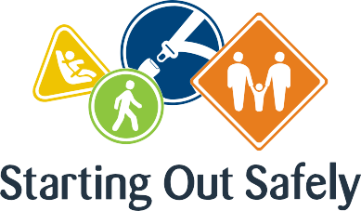

National Practice: Learning Environments

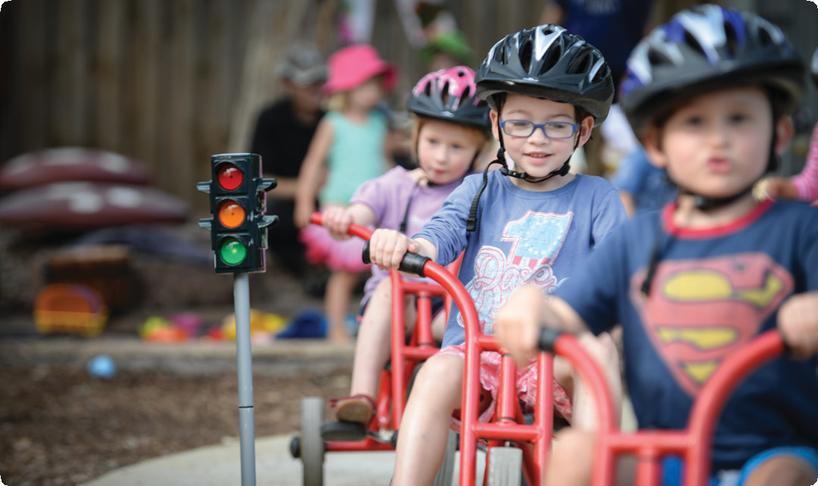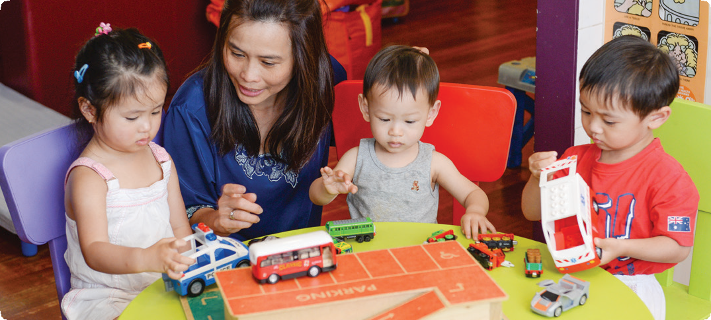**Provide opportunities in the learning environment, including the local community, for safe and meaningful interaction with children, parents and carers about road safety.**

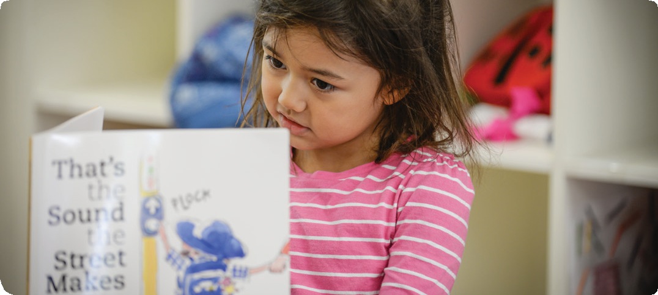

The learning environment is a visible representation of educators’ reflective practice, and demonstrates educators’ values in the learning spaces and materials offered.

Well-designed learning environments reflect children’s interests and promote meaningful play through the provision of ‘real life’ materials that reflect everyday life.

Learning environments conducive to road safety education include intentionally created indoor and outdoor spaces within a program, and in real road environments for example, during excursions and emergency evacuations.

Effective learning environments also include partnerships with families to support road safety education through program participation and the sharing of information

Connections

Early Years Learning Framework (EYLF)

“Environments that support learning are vibrant and flexible spaces that are responsive to the interests and abilities of each child” (*Belonging, Being & Becoming – The Early Years Learning Framework for Australia*, 2009 p.15).

National Quality Standard

**Quality Area 3: Physical environment**3.2: The environment is inclusive, promotes competence, independent exploration and learning through play.

3.2.1: Outdoor and indoor spaces are designed and organised to engage every child in quality experiences in both built and natural environments.

3.2.2: Resources, materials and equipment are sufficient in number, organised in ways that ensure appropriate and effective implementation of the program and allow for multiple uses.

Road Safety education in practice

**Case Study 1:** Providing rich learning environments can include storybooks that inspire children to consider the world around them.   
A group of four-year-olds in a long day program prepared for their community walk by reading the story Ruby’s School Walk by Kathryn

White and Miriam Latimer. The story is about what Ruby sees, or imagines that she sees on the way to school. Once out on their walk, the story prompted the children to really look at their surroundings and talk about what they were seeing as they walked. When they returned, the educator set out long rolls of paper on several tables to encourage the children to draw the things that they had seen on their walk.

The children were able to remember and draw many things including houses, people, roads, footpaths and road signs. This story shows us that we can help children to focus on specific aspects of their environment to aid awareness and memory, and to build on their road safety knowledge and understanding.

**Case Study 2:** Learning environments that support road safety education include spaces and places within the community. Educators at a children’s service located on the roof of an inner city building included the immediate streets, local square and shopping precincts when developing the procedures for their emergency evacuation plan. They also included visits to the surrounding area and specific evacuation sites as a regular part of the program. For the children, these spaces became part of their familiar learning environments, so that when evacuations took place, they were able to complete the process safely.

Practice suggestions

**Learning environments for children can be created from a wide range of materials and resources.**

Whether commercially-made, recycled, locally-sourced, borrowed or donated, materials and resources can enhance and support children’s learning about road safety. Some of the best resources are members of the community: family members or local workers.

Consider the following possibilities.

* Take photos of the local neighbourhood areas that children might see on their way to and from the service. These photos can be displayed in block construction areas or other learning environments to provide opportunities for children to recognise features of the road environment.
* Invite families to supply photos of their travels or adventures, and include them in learning spaces.
* Invite your local school crossing supervisor or police officer to visit, and engage children in thinking about what questions to ask visitors and how they might respond to the visits in their play.
* Provide small cars, bicycles and scooters in imaginative play areas.
* Use preloved road maps to support children to create their own maps of the journey to preschool.
* Provide dress ups for a variety of occupations including emergency workers, policemen/women and school crossing supervisors, and props such as steering wheels, chairs with ‘seatbelts’, large cardboard boxes and road signs.
* Use road play mats as an aid in talking about the street ‘furniture’ we see every day.
* Support children to set up a road crossing situation inside or outside. Encourage children to practice their safe road crossing skills by acting as pedestrians. This could look like a zebra crossing and become a working feature of the outdoor play space, as children on bikes practice to stop, and children practice waiting for a safe moment to cross.
* Encourage children to create a travel survey and ask each child how they travel to the service. This can be combined with numeracy, literacy and strengthening communication skills.
* Provide opportunities for children to use online maps to extend their understanding of roads and traffic.

**Further information** For more information about Starting Out Safely activities and resources please visit:<http://roadsafetyeducation.vic.gov.au/resources/early-childhood.html>