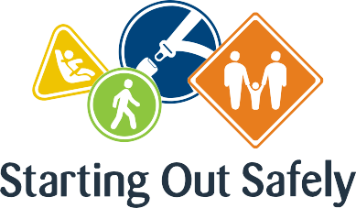

National Practice: Learning through play

**Through play-based learning seek opportunities to address road safety in a way that expands children’s thinking and encourages problem solving.problem solving.**

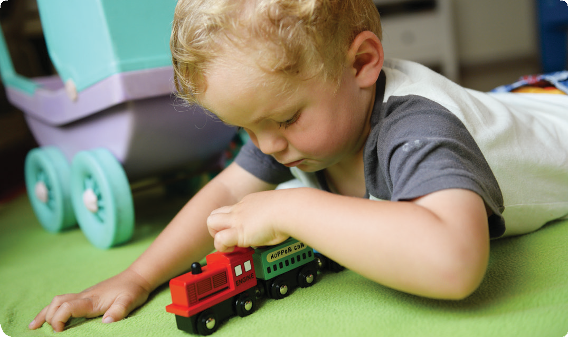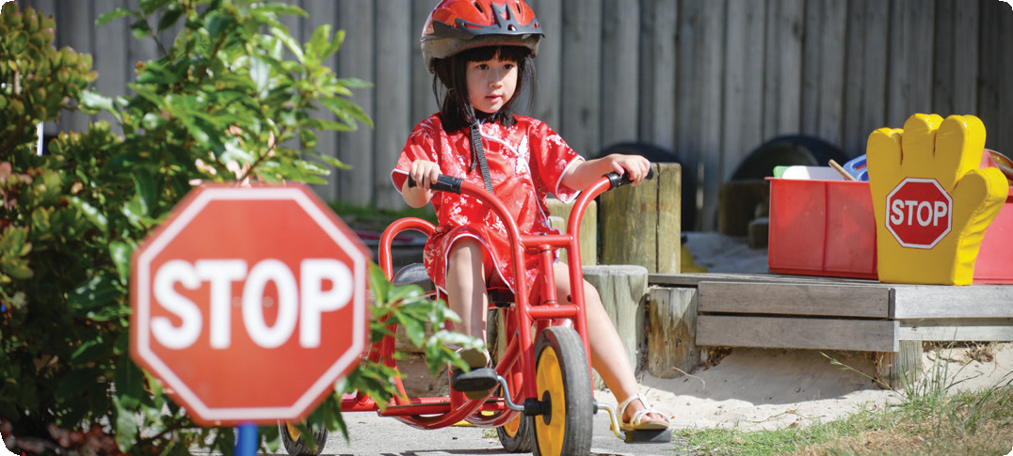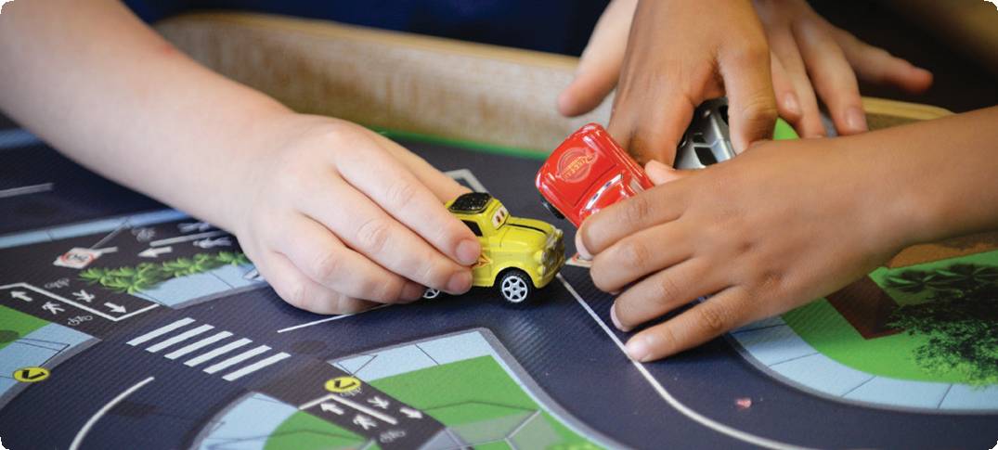

Play is a central component of effective early childhood education and care programs. Through play, children learn about themselves and the world around them. Play provides the opportunity for children to learn by doing and when the child is in control of the play, they can learn naturally, make choices and solve problems without fear of failure, fostering self-esteem and confidence for further exploration.

Thoughtful and reflective educators support children’s growing understanding of safety through play-based experiences and the provision of materials, space and sufficient time for full engagement. Supportive adults will extend children’s thinking by being a play partner, a role model and a guide to understanding safe behaviours.

Road safety education is enhanced when play underpins the whole curriculum and reflects children’s interests and strengths.

Connections

Early Years Learning Framework (EYLF)

“Play can expand children’s thinking and enhance their desire to know and to learn” (*Belonging, Being & Becoming – The Early Years Learning Framework for Australia*, 2009, p.15).

National Quality Standard

Quality Area 1: Educational program and practice

1.1: An approved learning framework informs the development of a curriculum that enhances each child’s learning and development.

1.1.1: Curriculum decision making contributes to each child’s learning and development outcomes in relation to their identity, connection with community, wellbeing, confidence as learners and effectiveness as communicators.

Road Safety education in practice

**Case Study 1:** Educators can encourage playful exploration in many ways. Sand and soil areas in the outside environment provide a perfect space for children to create their own scenarios and play with their ideas about roads, vehicles, traffic and keeping safe.

A small city children’s service received their annual delivery of sand to replenish the sand area. Instead of asking the families to relocate the sand as they normally would, they talked to the children about how they might relocate the sand from the big pile at the gate to the sand areas. The children worked together and devised a detailed system to deliver the sand to its new home that involved trucks and trolleys, pathways, and entries and exits. The educators used the opportunity to talk with the children about how they could keep everyone safe during the process. In response, the children developed more elaborate plans including gates and signs, and asked educators for hats and vests to keep safe when directing the trucks. The children’s playful exploration of this routine service task lasted several weeks and facilitated growth in the children’s understanding and awareness of how to keep themselves and their friends safe.

**Case Study 2:** Children also benefit from dramatic play opportunities where they can act out what they know and observe in their families and community life.

When a parent informed a service that he had just secured his first job as a bicycle patrol officer, the educators invited him to show the children his bicycle and uniform, and tell them about his work keeping people safe on the roads. The visit generated much discussion and excitement among the children. They were particularly impressed with the bicycle’s flashing lights, siren and bell.

The educators responded to the children’s enthusiasm by providing police shirts, bicycle helmets, tyres, traffic signs, blocks and a mounted steering wheel in the dramatic play area. Children pretended to be drivers in cars, cyclists and bicycle patrol officers.

The play allowed children to act out and make sense of what they had heard and seen during the visit.

Practice suggestions

**Play is central to children’s exploration of road safety.**

When children are supported to play through their ideas, they are provided with the opportunity to develop the skills, attitudes and understanding necessary to become safe road users. Educators might consider the following key ideas when encouraging children to engage in play.

* Support children’s play ideas and interests.
* Listen deeply to children and tune in to their questions or comments about the road environment either as passengers or pedestrians. Respond respectfully and accurately to their questions, thoughts and ideas, and join in with their play experiences to support and extend their understanding.
* Through observing children’s play, educators can evaluate and assess children’s individual strengths, interests and understanding of road safety, and plan experiences that support further engagement and participation.
* Act as a guide during play, assisting children to use and include safe road strategies, for example safe practices for crossing the road (stop, look, listen and think).
* Set the environment to support children’s exploration and engagement of road safety by providing:
* open-ended resources and equipment such as blocks, cars, signs and other building equipment, that can be freely chosen by children, will stimulate imagination and can be used in a variety of different ways to explore children’s understandings of the road environment
* extended play time to explore ideas and concepts related to road safety. Educators can support these extended play opportunities with resources and specific information that engages children’s thinking and understanding.
* Invite children to undertake their own travel survey about how children and families arrive at the service. Children could also map and analyse this data.

**Further information** For more information about Starting Out Safely activities and resources please visit: <http://roadsafetyeducation.vic.gov.au/resources/early-childhood.html>