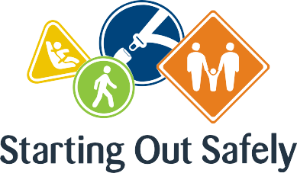

National Practice: Responsiveness to children

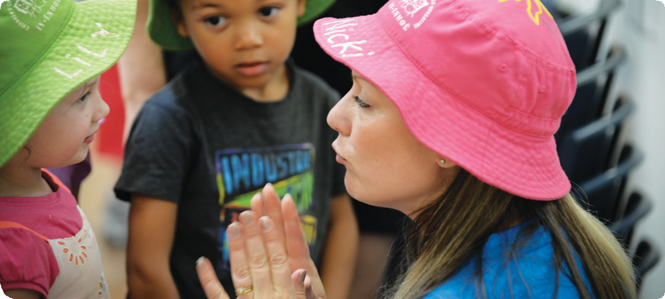**Deliver road safety education which is responsive to individual children and extends children’s strengths, knowledge and interests.**

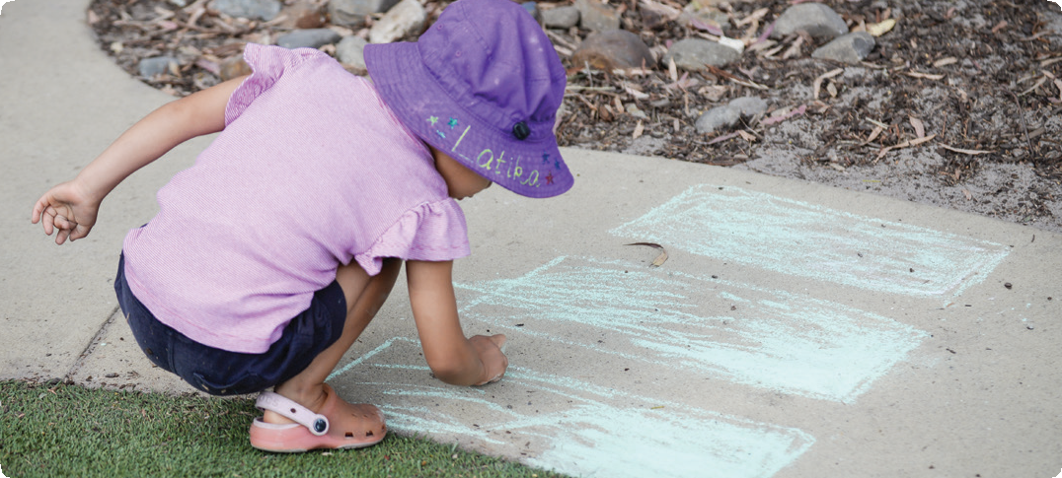

Being responsive to children allows educators to offer programs that support children’s being, belonging and becoming. Responsive practice requires educators to notice the unique aspects of children’s lives and to build curriculums that reflect these attributes.

When we tune in to who children are, the things that are important to them and their families, and the context of their community, we are better able to extend their understanding, knowledge and interests.

Road safety education experiences that reflect what children know and who they are, equip them and their families to participate safely in their own communities.

Becoming responsive enables educators to make meaningful decisions about how to embed road safety education into the daily curriculum.

Connections

Early Years Learning Framework (EYLF)

“Educators are responsive to all children’s strengths, abilities and interests. They value and build on children’s strengths, skills and knowledge to ensure their motivation and engagement in learning” (*Belonging, Being & Becoming – The Early Years Learning Framework for Australia*, 2009 p.14).

National Quality Standard

**Quality Area 5: Relationships with children**

5.1: Respectful and equitable relationships are developed and maintained with each child.

5.1.1: Interactions with each child are warm, responsive and build trusting relationships.

5.1.2: Every child is able to engage with educators in meaningful, open interactions that support the acquisition of skills for life and learning.

Road Safety education in practice

**Case Study 1:** Responsiveness can also include modifying existing approaches to make programs more accessible and safer for children to attend. A children’s service in a busy country town was supporting William, a child with additional needs, who found arrival and departure particularly stressful. William’s parents had informed the service of his challenging behaviour and that he had escaped several times as they were leaving friends’ houses and had run off down the road. William had also managed to free himself from his child restraint while in the car, adding to his parents’ anxiety about keeping him safe.

Educators worked with William’s parents to design an arrival and departure procedure to help manage these times effectively. It was agreed that William’s parents would arrive at the service slightly later in the morning, and at departure time, educators would help William to choose toys that he could borrow to continue his play at home. The service’s educators also contacted a local specialist support agency to seek assistance for William’s family to help support his behaviour in the car and to discuss child restraint options.

**Case Study 2:** Responsiveness is essentially about listening to the needs and interests of children and working with them to maximise learning opportunities. A good example occurred at a sessional kindergarten program with a group of four-year-old children.

A child arrived one morning with a real estate brochure advertising the new house his family had just purchased. With the help of a local map, the educator led a detailed discussion about where his new house was in relation to his old house and the kindergarten, and how he would travel to kindergarten once he moved. The other children were also engaged in this discussion about the local community and used the map to try to locate their own houses.

The educators responded to these conversations by visiting a local real estate agent to collect additional housing brochures. The children then used these brochures to create a collaged map of their local neighbourhood. The project expanded to include mapping of children’s houses, traffic lights and crossings, and important local places such as shops and the school. The educators and children then decided to visit the neighbourhood they had mapped and took excursions to children’s homes, local shops and the school. These experiences helped to develop the children’s road safety awareness, knowledge and behaviours as well as their understandings of community and citizenship.

Practice suggestions

**Being responsive to children is enacted in many different ways.**

Sometimes, it means actively joining with children in play, while at other times it can be about providing materials and resources to support ideas and extend thinking. Responsiveness can also be the quiet interaction made with children that draws them into the program and enables their participation. Being responsive in early childhood road safety education might be enacted in the following ways:

* Listen to children, especially their understanding of their own experiences as road users in their local community. This is a powerful opportunity to learn more about what children know, to support the development of new skills and to provide timely learning opportunities that reflect children’s interests.
* Make time to speak with families about their child/ren’s experiences at home and with extended family. This may provide information to inform curriculum decisions.
* Consider opportunities in the enrolment process (interview questions, enrolment information or forms) to gain information about how families arrive at and depart from the service, and any particular challenges that this might present, e.g. children with additional needs, involvement of grandparents etc.
* Educators, children and families could work together to develop community-specific resources that reflect road safety messages relevant to their community context and share this with families, e.g. ‘slow down’ signage for the service’s car park.

**Further information** For more information about Starting Out Safely activities and resources please visit: <http://roadsafetyeducation.vic.gov.au/resources/early-childhood.html>